Changes to Home Extensions Rules

If you are planning a single-storey rear extension, after the 30 May 2013, the following changes will apply to you. This change does not affect side extensions, which should continue to apply the existing permitted development requirements.

Detached Houses
If you have a detached, family home and want to build a single-storey, rear extension of between 4 metres and 8 metres deep from the original rear wall of your house, you will need to apply to the council’s Planning Team to find out if Prior Approval is needed before you can build your extension. In this case, the Prior Approval process replaces the need for Planning Permission.

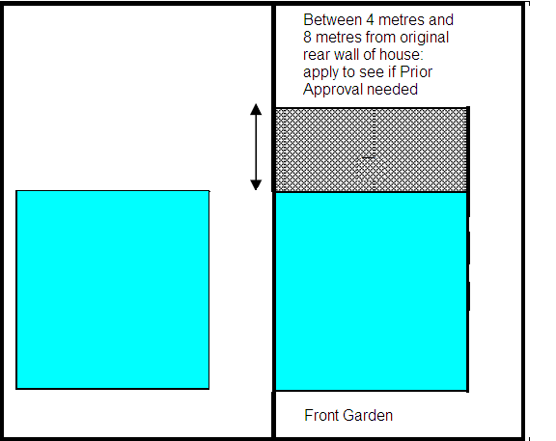

Semi-detached or terraced houses
If you have a semi-detached or terraced family house and want to build a single-storey rear extension which is between 3 metres and 6 metres deep from the original rear wall of your house, you will need to apply to the council’s Planning Team to find out if Prior Approval is needed before you can build your extension.

When is Planning Permission Needed?
In general, Planning permission will be needed for your single-storey rear extension if:
- If it would mean that your house, extension and any out-buildings that you have, would cover more than 50% of the garden which surrounds your house;
- It would be more than 4 metres in height to the tallest part;
- The eaves would be more than 3 metres high;
- It includes a balcony, veranda or raised platform;
- It includes a chimney, flue or soil and vent pipe;
- It includes a microwave antennae;
- The materials you use do not match your property;
- Your property has been extended in the past and your new extension would add onto this or;
- The Council has restricted the alterations that can be made to your property.

What about houses in Conservation Areas?
Planning permission would still be needed for single-storey rear extensions to dwellings in Conservation Areas, where they are deeper than 4 metres from the original rear wall, in the case of a detached house, and greater than 3 metres from the original rear wall in any other case. The criteria listed above under “When is Planning Permission needed?” also apply in the case of Conservation Areas.

In some Conservation Areas there are further restrictions on what alterations can be carried out to houses, so it is always advisable to check with one of the council’s Duty Planning Officers first.

What is Prior Approval?
If your extension does not meet certain criteria or, if any of your neighbours object to your extension plans, then the Council’s Planning Team will need to decide if they can approve your plans to build, before you start any works.

What do I need to submit to Planning to find out if I need Prior Approval?
You will need to provide us with the following information:
- Your name, address and contact details;
- Confirmation in writing of how far out the extension will come from the original rear wall of your house;
- Confirm in writing what the height to the eaves of the extension will be;
- Confirm in writing what the height to the highest part of the extension will be;
- Confirm in writing the addresses of your neighbours;
- Provide a plan showing your property and the footprint of the extension and;
- Provide a plan showing what the extension will look like.

The plans do not need to be drawn by an architect but they should be clearly drawn and, if not to scale, then all the dimensions marked on them.

How is it decided if Prior Approval is needed or not?
We will write to your neighbours and give them a chance to write into us with any concerns. If any letters raising objections are received from your neighbours, then Prior Approval is needed.

What happens if Prior Approval is needed?
The Council will decide if the extension would have an unacceptable impact on your neighbours either through, for example, a loss of light, over-shadowing, a loss of privacy or whether the extension would appear over-bearing or, make neighbouring properties and gardens feel enclosed. If the Council decide that the extension would not be harmful, then they will send you a notice which grants Prior Approval.

What happens if Prior Approval isn’t needed?
The Council will confirm this by sending you a notice.

How long does this take?
The Council will send you a notice letting you know the outcome within 42 days of them receiving the required information.

What do I do if Prior Approval is refused?
You can appeal the decision. Details of how to do this will be on the notice that the Council sends you.

Do I have to do anything else?
The extension will need to be finished before the 30th May 2016 and you will need to write to the Planning department to confirm when you have finished your extension.

You will also need to check to see if you need Building Regulations approval for the extension before you start. Details of how to do this can be found on the Building Control page

Smaller Extensions
If you have a semi-detached or terraced property, and want to build a single-storey rear extension of no more than 3 metres deep from the original rear wall of the house, then you do not need to go through the Prior Approval process. The criteria outlined above, under “When do I need Planning Permission?” will still apply to you.

If you have a detached property, and want to build a single-storey rear extension of no more than 4 metres from the original rear wall of the house, then you do not need to go through the Prior Approval process. The criteria outlined above, under “When do I need Planning Permission?” will still apply to you.

The new legislation which outlines these changes can be found Town and country planning act - 2013 No 1101

