Getting to good and maintaining it survey
Overall, there were 13 respondents to the survey between 02/12/16 and 16/01/17.
To what extent do you agree or disagree with the following statements?
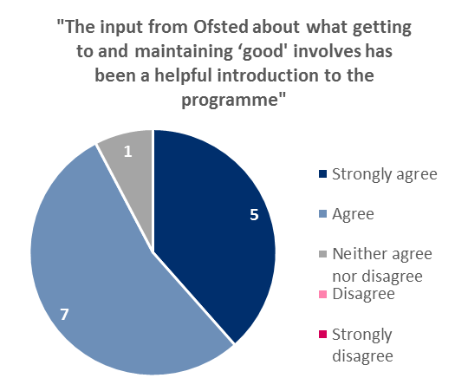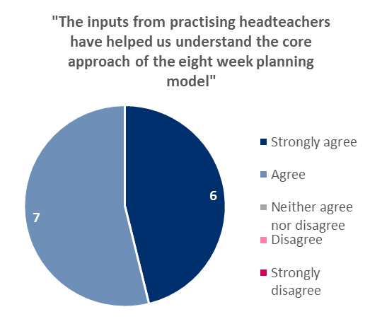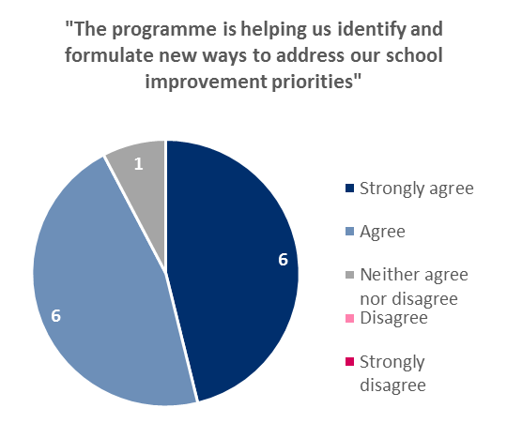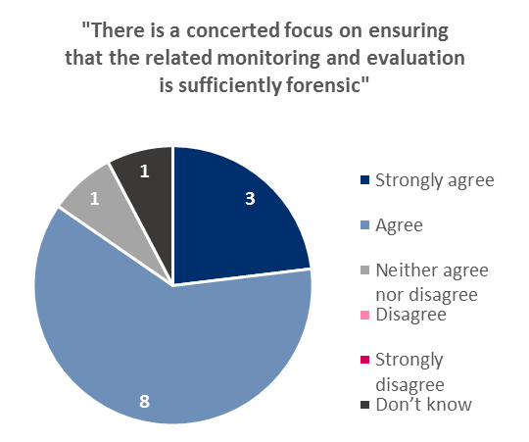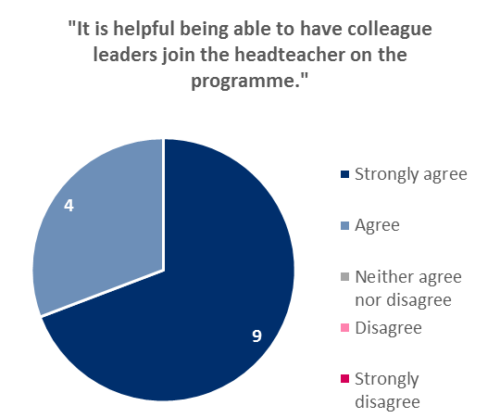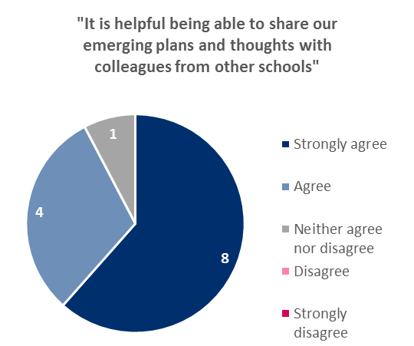
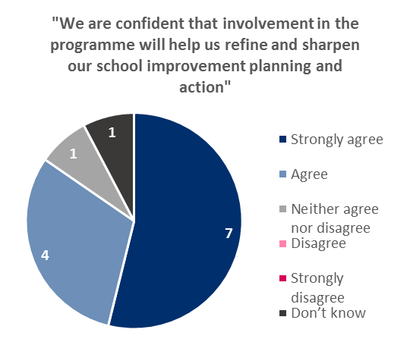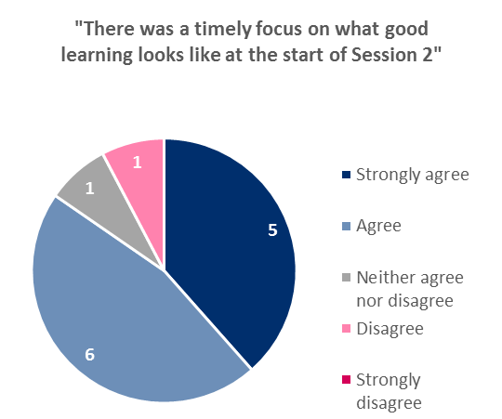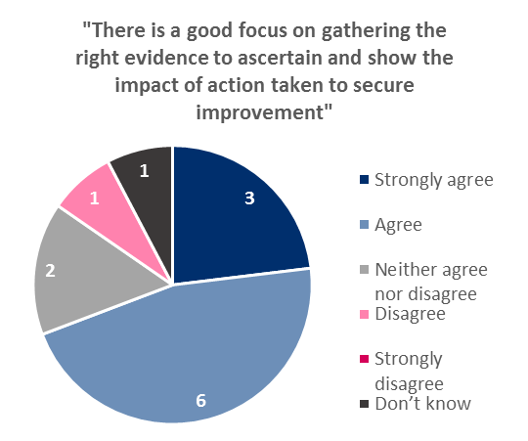
Comments:
Quote | Comments
"The input from Ofsted about what getting to and maintaining ‘good' involves has been a helpful introduction to the programme" | - Really excellent to hear about model outcomes from other schools. Clarity in delivery with some key aspects of improvement that we have alrea  - Unfortunately there is a disconnect between what Ofsted say and what Ofsted do. There is still inconsistency in how teams carry out inspecti
"The inputs from practising headteachers have helped us understand the core approach of the eight week planning model " | - Really enthused by examples shared and both electronically and physically.  - The two visiting HTs relayed good examples of the journey to 'Good'.  - It was useful to hear from other Headteachers
"The programme is helping us identify and formulate new ways to address our school improvement priorities" | - The programme has helped us to focus on a specific priority.  - The programme has helped us to really focus on a specific development area. It has also given an opportunity to engage in a different approa  - We already used a version of the 8 week plan. This has sharpened up our use of it and helped us to have a single focus.  - We have launched our eight week programme - all stakeholders informed - children fully engaged and Pupil Leadership Team carried out Ward Wal  - We have taken on board the aspect of 'whole school' focus and have added what outcomes will look like for learners, staff, parents and govern
"There is a concerted focus on ensuring that the related monitoring and evaluation is sufficiently forensic" | - Baseline and monitoring a priority.
"It is helpful being able to have colleague leaders join the headteacher on the programme." | - As a cluster we have the same focus and another school within the cluster have also joined in.  - It is always useful to share views and ideas with other leaders.  - Our Sholing Cluster are all involved and have same focus.
"It is helpful being able to share our emerging plans and thoughts with colleagues from other schools" | - I believe that it would have been more productive if each school had presented their plan to a 'support group' to receive feedback. I also th  - Talked through plans on our Peer Review day at Bitterne CE and have liaised with university and Miranda over a spelling focus for research.  - This is an opportunity rarely open to leaders.  - We think it would have been better for each school to present their plan at this stage rather just wandering around looking at each other's p
"We are confident that involvement in the programme will help us refine and sharpen our school improvement planning and action" | - All staff have engaged with the programme and are enthusiastic.  - It will provide an accountable focus for us.  - The eight week programme will be our way forward.
"There was a timely focus on what good learning looks like at the start of Session 2" | - Used this on INSET day this week and all staff including admin and site teams now have learning booklet and shared understanding.  - We feel this time would have been better spent on what leadership strategies best bring about improvement. We already know what good teaching
"There is a good focus on gathering the right evidence to ascertain and show the impact of action taken to secure improvement" | - I do not think that this area was looked at in enough detail.

Further comments:
Have found that our involvement in this programme has already had an impact and been incredibly valuable. Sorry I didn't complete this before.
My Deputy and I are very pleased to be given the opportunity to be part of this supportive programme and are using it to support further training for all staff in school.
Overall we have found the course useful.
So far, it has been a positive experience to engage with other leaders on such a programme.
Thank you for letting us be part of this development opportunity
This programme will make us focus on an area that needs to be addressed (spelling - probably by all schools!) and I hope will provide evidence for Ofsted that we are trying to overcome the problems created by a new curriculum, new assessment framework and new accountability systems. And also being a Junior School!

