Serena’s Floristry Sessions

Our First Issue!
• • •
We hope you enjoy our very first issue. Just a taster of everything we get up to here at Southampton Day Services.
Paul and the team have been pottering away at this for weeks and would appreciate any feedback, articles or ads you may want us to feature. Please get in touch: paul.smith@southampton.gov.uk
SOUTHAMPTON DAY SERVICES
April 2017 | Southampton City Council | Issue 1

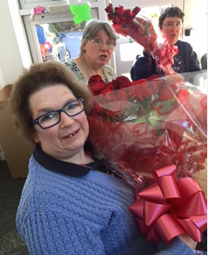
  - Supported by Sweet Pea Florist
Over The past 6 months we have had the ever so lovely Serena from Sweet Pea Florist in Woolston come and run some sessions in both of our bases. She has been leading the sessions and worked very well with our Service Users to produce some excellent works of art! From flower arrangements, to making lanterns for Chinese New Year, to planting mini sensory gardens in plant pots for the Service Users to take home.
“I had the best time working with the service users and coming up with ideas for them to make. It really was enjoyable, especially the mini sensory gardens.” - Serena

Tremaine’s Death-Defying Feat
Parachute jump for Cancer Research
Tremaine Lovell, one of our Project Officers, recently raised a bucketful of money for cancer research by a parachute jump out of a plane. Well done Tremaine and for such a good cause. Altogether she raised a whopping £2220.00. Well done Tremaine, we are very proud!

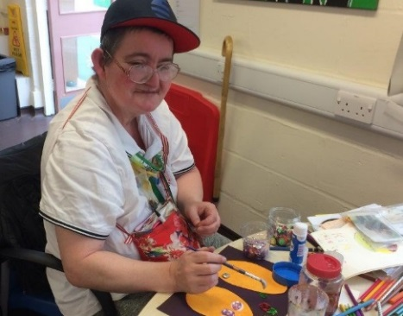
Service User Spotlight
Sally Smith
Over the past few months Sally has been very engaged with a few projects during her arts session. Jane Carter, one of our Development Officers, has been doing some great 1to1 work with her, and supported her to use the sewing machine to make herself a new shopping bag. She has always been producing some great pieces of work which involve planning in rough first, then making the final product. Well done Sal, keep up the great work.

Red Nose Day Cake Sale
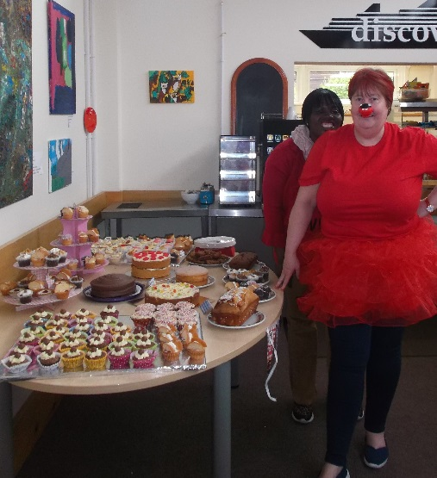
Written by Lin Sherman
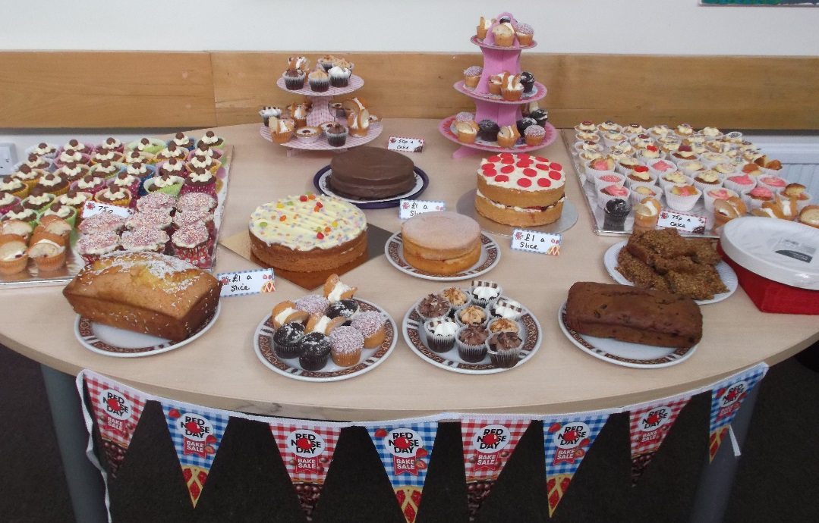
Red Nose Day cake sale was a great success with most of the service users and staff turning up wearing something red and they looked brilliant. There were a lot of cakes donated – both homemade and shop bought. The table looked brilliant when set up. We also had a raffle during the morning and together with the cake sale, we managed to raise £280.00.

The Sembal Committee were very kind and matched this therefore we raised a whopping £560.00! I would like to thank everyone for bringing cakes in and taking part in a very successful morning.

Bex’s Fun Fact!
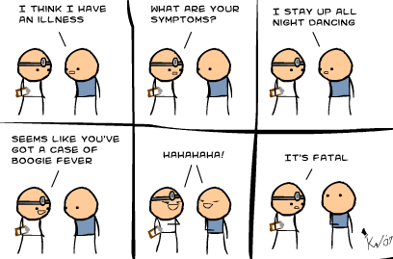
Rebecca Beusmans, Development Officer.
When hippos are upset, their sweat turns red

Baby Boom!
Maternity leave.
2 members of our team will be leaving us for a while to go on maternity leave. Nicki Parsons (Project Officer) & Agi Campbell (Development Officer) have endless nappy changes and sleepless nights to contend with for the foreseeable future! We, as a team, wish them all the best and hope they both enjoy the first incredible chapter of Motherhood. They shall be missed!

OTARS Football Penalty Shootout
  - Supported by Great Oaks School and Matt LeTissier’s Football Academy.
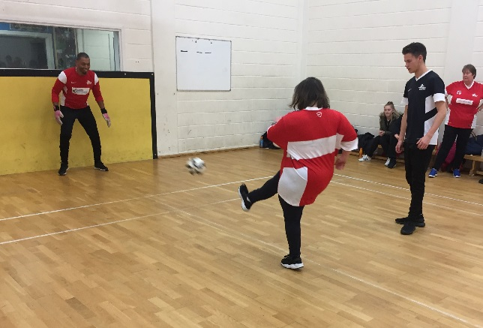
OTARS held a sponsored penalty shootout on the 2nd March at Great Oaks School. The football session has been running for well over 2 years now and is also held at the Sports Centre over the summer months. Set up by Nicki Parsons and now run by Lin Sherman, this evening activity is very popular and very much a social occasion with friends and families coming along to watch and cheer the players on.
“The football sessions themselves are a delight to be part of. Each of the guys have progressed so well during the past two years. I would recommend anyone to volunteer for this session.” - Lin
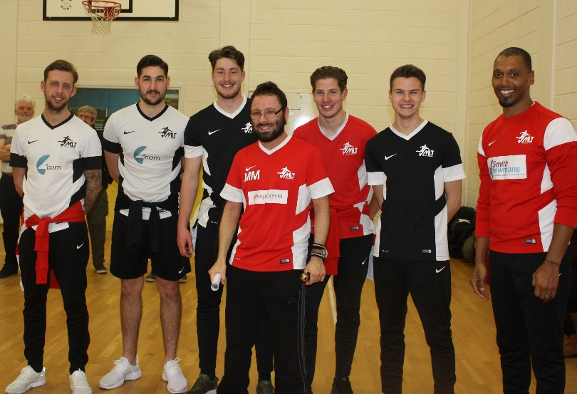
Coached by Matt LeTissier’s Football Academy and often visited by Saints Professionals such as Pele and Matt himself, this sessions offers adults with learning difficulties or physical disabilities a chance to gain the skills passed on from the coach and to participate in matches against other teams.
“The OTARS penalty shootout was a brilliant success. Our coach, Pele, turned up for the session bringing 5 other coaches from Matt Le Tissier’s coaching academy. Everyone had an amazing time. The coaches were brilliant and commented on how well our guys were doing. Our very first coach – Ben Jefford turned up as well and when I spoke to him, he said how much of a change he had seen in everyone particularly the girls who he thought were as good as the boys. The hall was packed with people having fun It was such a pleasure to be part of it and a lot of money was raised for OTARS while we had fun.”- Lin.
This penalty shootout gave our athletes the chance to get involved in the fundraising by getting their friends and families to sponsor them. The evening was a great success and they raised £428. Many thanks to Lin, Nicki, and everyone who helped make this event a success.

Southampton Day Services: Bringing people together

