Ref: PP/KR 27 October 2020

Dear Supplier,

COVID-19 pandemic and payments to suppliers

I am writing again to thank you as a valued supplier for helping Southampton City Council maintain its critical services and supplies during the COVID-19 pandemic.

This letter updates our letter of 6th April 2020 and sets out the approach we will be taking from 1st November 2020 to paying and working with our suppliers in accordance with the government guidance in Procurement Policy Note - Supplier relief due to COVID-19 (“PPN 02/20”), which was supplemented on 9th June by Procurement Policy Note - Recovery and Transition from COVID-19 (“PPN 04/20”).

The government guidance in PPNs 02/20 and 04/20 ceases to have effect on 31st October 2020.

As advised in PPNs 02/20 and 04/20, the Council has been seeking to pay all its suppliers as quickly as possible. With effect from 1st November 2020 the Council will be reverting to payment of suppliers in accordance with its standard terms and conditions or in accordance with the contractual terms set out in your agreement with the Council. Please continue, where possible, to submit your invoices to invoices.only@southampton.gov.uk , rather than sending them by post. This allows for more efficient processing.

The Council recognises that these continue to be challenging and uncertain times and remains committed to supporting its suppliers as the pandemic evolves. Please therefore continue to work closely with your Council contract manager to continue to provide your valued services, goods and works. Your efforts to support the Council, the city and our residents are greatly appreciated. Thank you.

Yours sincerely

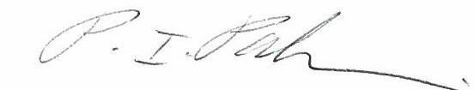

Paul Paskins
Head of Supplier Management
Email: supplier.management@southampton.gov.uk

