55558



**Disabled Children’s Service Children’s Social Care Threshold and Eligibility Criteria**

**Southampton City Council**

**Date: April 2019**

**The Vision for Southampton Children and their Families:**

*“We want Southampton to be a city where parents, families, communities and services work together to make sure children and young people get a good start in life.”*

*2020 Vision for Southampton’s Children and Young People*

Helping Children and Young People to get a good start in life – our priorities:

1. **Healthy and Happy;** Children in Southampton live happy, healthy lives, with good levels of physical and mental wellbeing.
2. **Safe and Secure;** Children in Southampton are safe at home, safe in the community and safe online.
3. **Resilient and Ready;** Children, families and communities are resilient, engaged, prepared for the future and able to help themselves and each other to succeed.
4. **Achieving and Aspire:** Children in Southampton have good levels of educational attainment. Fulfil their potential, and go on to successful opportunities in adulthood.

All disabled children and young people have the right of access to universal health, education and community based support services.

They also have the right of assessment for specialist health, education and social care services. These rights are enshrined in the UN Convention on the Rights of the Child and the Children Act 1989. They are reinforced by, the Equality Act 2010 and the Children and Families Act 2014

The threshold and eligibility criteria for access to specialist services provided by the Disabled Children Service aims to ensure a fair, transparent and proportionate response to the assessed needs of disabled children, young people and their parents and carers. Eligibility for a specialist service provided by the Disabled Children Service is determined by an appropriate assessment of need under statutory guidance. The general statutory duty to provide services under the Children Act 1989 Part II is triggered by the Local Authority determining that the provision of services is appropriate to the assessed needs of a child. The enforceable duty under the Chronically Sick and Disabled Persons’ Act 1970 (s2) is triggered by the Local Authority being satisfied that services are necessary to safeguard the welfare of a disabled person.

The most appropriate and relevant service for a disabled child or young person is based on what is in the best interests of the child or young person, within the available resources of Southampton City Council and partner services . The aim is to ensure that the available resources are targeted to benefit those children in most need, including those at risk of significant harm, and that proper consideration is given to equity of provision underpinned the needs outlined within the assessment.

This document should be read in conjunction with the Southampton Local Safeguarding Children Board Continuum of Need Level Indicators (Appendix 1), where the needs of children and their families are described as a ‘continuum of need’ which can be differentiated into four levels:

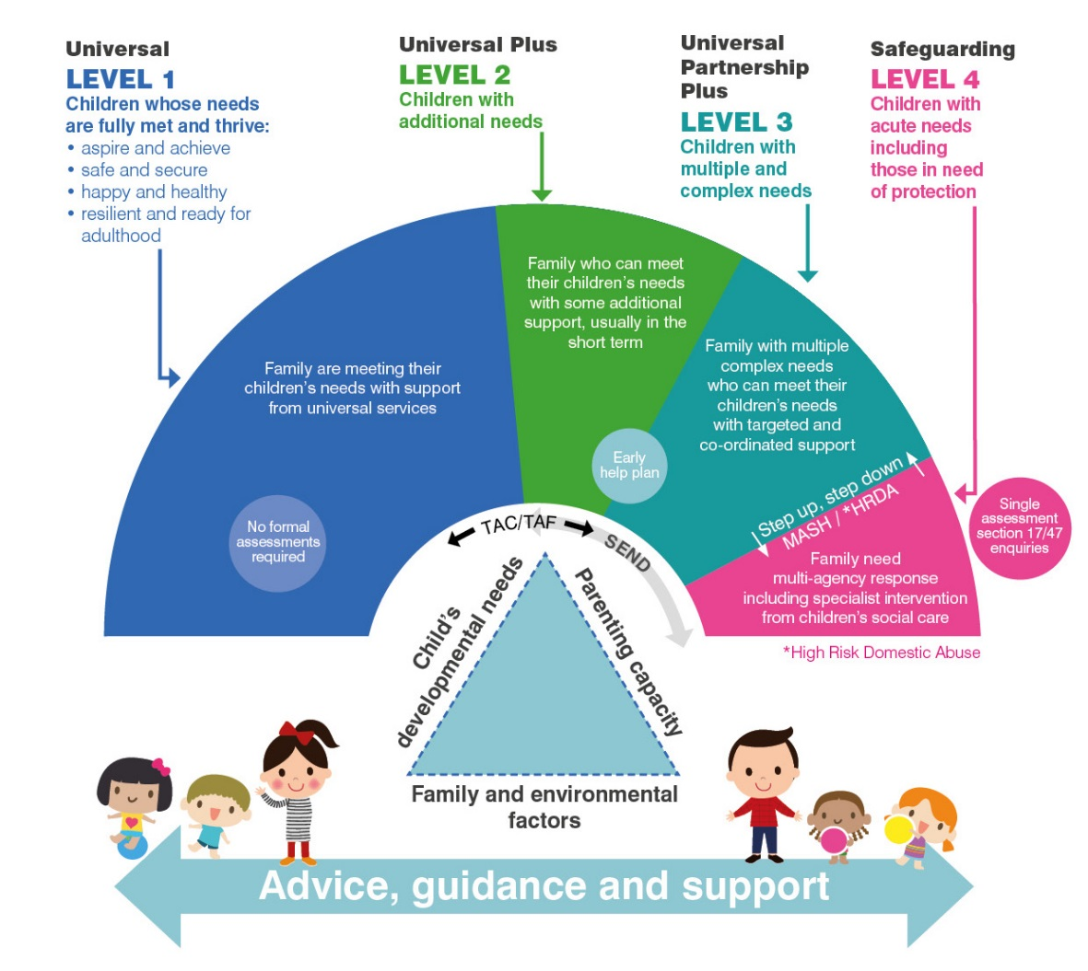

* **Universal (Level 1)** *Children whose needs are fully met and thrive* – Essentially a child’s needs are understood to be met.
* **Universal Partnership (Level 2)** *Children with additional needs* – Some concerns may be addressed within a single agency through its own internal consultation procedures. In some instances, concerns may be addressed through joint or multi-disciplinary consultation or referral – with or without the need for professionals from different disciplines or agencies physically coming together to meet. A family may seek the support of a service in accessing additional support with for example parenting, the local offer (SEND) or health related concerns.
* **Universal Partnership Plus (Level 3)** *Children with multiple complex needs* - Where a child or public safety is not an issue, but there are other concerns, a multi-agency meeting (Team Around the Child/Family TAC/TAF meeting, Education Health and Care Plan Review, etc.) provides the multi-agency planning forum: this may involve practitioners from any of the **universal, universal plus, universal partnership plus services** - whether statutory or private, voluntary, independent or community services
* **Safeguarding (Level 4)** *Children with acute needs including those in need of protection* - In cases where:
* the protection of a child is an issue, a Strategy Discussion is held, and if followed by a Child Protection Enquiry a Child Protection Conference may be convened- as outlined in the *Southampton LSCB Child Protection Procedures*
* where public protection is at risk, the Police will lead on co-ordinating a response: this is likely to involve *Multi-Agency Public Protection Arrangements* (MAPPA) corresponding to three categories of offender (involving violent or sex offenders) and three levels of risk management (involving more intensive multi-agency engagement)
* where a young person is subject to a statutory youth offending order, where the likelihood of re-offending or risk of serious harm is high, internal processes take place to assess interventions required and participation of other agencies
* where an Education Health and Care Plan needs to be considered for *Children with Special Education Needs and Disabilities* a multi-agency statutory assessment is undertaken.

**How the Southampton Continuum can be applied to Disabled Children.**

Children who have a disability can move between these levels of need according to their particular circumstances and the positive impact of advice, help and support. Service responses need to be flexible to address the changing needs of children and their families. The different levels of need trigger different assessments and service responses. Assessments make the best use of inter-disciplinary and multi-agency consultation to ensure that appropriate services are put in place.

Eligibility can be assessed in terms of a child’s needs as: Low, Medium, Substantial or Complex.

**Low**

Children are supported by their families with the involvement of local friends, the community and universal services. For these children and young people and their families the appropriate support services are universal services that do not require a specialist assessment.

**Medium**

Children and/or their families have additional needs that cannot be met by universal services alone. This can include a child or young person where their needs are not clear; not known; or are not yet being met. This may require additional help from a single agency (Level 2, Universal Plus) or a co-ordinated response from more than one agency (Level 3, Universal Partnership Plus). If a multi-agency response is considered appropriate then this could trigger an Early Help Assessment (EHA), if no prior assessment in place and an Early Help Plan within a Team around the Family (TAF) approach - additional support can be delivered through the short break programme. The EHA may conclude that a combination of universal and targeted services is required to meet the child’s needs. Requests for Early Help Services can be made in a number of ways, primarily direct to those services provided internally or commissioned as part of a wider programme of services.

**Substantial**

Children with complex needs are likely to require a specialist assessment for longer term intervention from statutory and/or specialist services. High level, additional needs that remain unmet despite support from targeted services may require an integrated response that will usually include statutory service. This is the basis of the threshold for a child in need under the terms of the Children Act 1989 (Section 17) which may result in statutory social work intervention and can include children in need of protection (Section 47) where this isn’t linked to or the impact of a child’s disability.

**Complex**

Children with acute needs may require intensive, statutory support from specialist health and/or social care services in line with the JIGSAW (Children with Disabilities Team) criteria.

JIGSAW (Children with Disabilities Team) is a specialist and statutory multi-agency health and social care service that undertakes assessments and provides services at the complex level of needs.

The Team supports disabled children, young people and their families whose main need for service arises from their disability or their intrinsic condition, and where these conditions have a complex impact on the quality of the child’s life or/and the lives of their families.

The Service intervenes where their needs cannot be fully met by universal and targeted services alone.

Children are defined as ‘children in need’ by the Children Act 1989 because of their disability. Some of those children are also assessed as having complex needs that may require specialist support from JIGSAW (Children with Disabilities Team), in addition to universal and targeted services, because they have disabilities or illnesses that are severe and enduring, including one or more of the following;

* Learning disabilities within the moderate, severe or profound range as defined by ICD 10 criteria - [Click here for ICD 10 Criteria](http://apps.who.int/iris/bitstream/10665/37108/1/9241544554.pdf)
* A severe physical (including visual and hearing) health condition or impairment which is life limiting, or significantly affects, or is predicted to affect, everyday life functioning or a child’s access to education (e.g. in a wheelchair, has adapted living, requires total personal care support, requires communication aids) and their ability to achieve outcomes appropriate to their age related potential. These children are likely to be subject to Children’s Continuing Care Arrangements because of the complexity of their health needs or an Advance Care Plan. They may also have Autism, and their behaviour is likely to present a serious risk of harm to self or others.

Other disabled children may have additional needs but the impact of their disability on their day to day living arrangements means that they do not require specialist statutory support and their needs can be met appropriately with additional support from universal and targeted services, including mainstream Children’s Services.

|  |  |  |  |  |  |  |  |
| --- | --- | --- | --- | --- | --- | --- | --- |
| **Areas of Need** | **Complex** | **Factors taken into consideration** | **Substantial** | **Factors taken into consideration** | **Medium** | **Factors taken into consideration** | **Low** |
| Child | Learning disabilities/within the moderate, severe or profound range, in accordance with ICD 10 criteria.  A severe physical (including visual and hearing) health condition or impairment which is life limiting, or significantly affects, or is predicted to affect, everyday life functioning or a child’s access to education (e.g. in a wheelchair, has adapted living, requires total personal care support, requires communication aids) and their ability to achieve outcomes appropriate to their age related potential. | Support for all basic self-care functions.  The need for constant supervision throughout the day and for prolonged periods at night, when no longer age appropriate.  Behaviour exhibited as a result of disability presents a serious risk to self or others, including self-harm / injury.  The use of specialist equipment for mobility, respiration, feeding, cardiac or neurological functioning.  Advance Care Plan / Continuing Health Care Arrangements.  Communication needs which, without support, severely affect personal safety i.e. visual impairment, hearing impairment, physical impairment or without speech.  Without support the child will have unmet needs, be at risk of significant harm or need a specialist residential educational placement. | Learning or physical disability that significantly impacts on a child or family’s ability to function.  The impairment, chronic health and life limiting condition have a substantial impact on the quality of the child and their family’s life.  Child would be unable to achieve outcomes without support from targeted services, coordinated by a lead professional. | Child likely/could be requiring continuous care that is not appropriate to age related potential.  Some risk taking behaviour or mental health needs which presents a significant risk to self of others, including self-harm.    Child likely to attend specialist education provision.  Child may have an EHC Plan.  Without support child will have unmet needs and be at significant risk of harm.  Danger of child moving into complex domain. | Child has a complex health condition or Special Educational Need or Disability.  Less severe impact of impairment upon child.  Needs cannot be met by universal services alone.  . | Child wishes to attend peer group social event but needs adult assistance to access it.  Child could be independent in self-care with adult guidance or adaptations available.  Child may have an EHC Plan.  May require programme of short term intervention e.g. Portage, SALT, OT, CAMHS, School interventions including SENCO and ELSA support.  Child may require access to specialist playschemes or enhanced universal provision through additional staffing or specialist equipment. | Child whose independent living skills are slightly impaired by a level of disability but their needs can be met by advice and to access universal services.  Example signposting to mainstream provision such as leisure activities or other independent organisations. |

|  |  |  |  |  |  |  |  |
| --- | --- | --- | --- | --- | --- | --- | --- |
| **Areas of Need** | **Complex** | **Factors taken into consideration** | **Substantial** | **Factors taken into consideration** | **Medium** | **Factors taken into consideration** | **Low** |
| **Parent** | |  | | --- | | Parent/Carers (or others in the family home) has physical or mental health difficulties or learning disabilities.  Parents unable to meet needs without significant support from specialist services and social network. | | Sole parent/carer.  Parent/carer has impairment / learning disabilities.  Parent has physical or mental health difficulties.  Parent has alcohol or substance misuse issues.  There is an actual risk to the health and safety of parent carer.  The carer suffers prolonged sleep deprivation on a regular basis, due to the needs of the disabled child through the night.  Without the provision of Short Breaks from their caring responsibilities, including outreach services or the appointment of a Personal Assistant or some overnight respite, parents will be unable to continue with their caring role. | The impairment, chronic health and life limiting condition have a substantial impact on the quality of the child and their family’s life.  Danger of child moving into complex  domain. | Child likely/could be requiring continuous physical care.    Provision of services similar to complex but not an immediate intervention required.  Require some breaks from caring through outreach services or the appointment of a Personal Assistant. | Less severe impact of impairment upon parent.  Parents require support for children with additional needs above what is available at universal level e.g. Special Education Information, Advice and Support, Benefits, carers rights etc.  Require some breaks from caring e.g. Playschemes and activity clubs. | Child wishes to attend peer group social event but needs adult assistance to access it.  Child could be independent in self-care if adaptations available. | Parents are able to meet needs through universal services and network of family and friends.  Parents may require signposting to SEND Local Offer for information, advice and guidance and universal services available. |

|  |  |  |  |  |  |  |  |
| --- | --- | --- | --- | --- | --- | --- | --- |
| **Areas of Need** | **Complex** | **Factors taken into consideration** | **Substantial** | **Factors taken into consideration** | **Medium** | **Factors taken into consideration** | **Low** |
| Family and Environment | |  |  | | --- | --- | |  | . | | The disabled child has been / or is the subject of a child protection plan.  There is a risk to the disabled child because of the physical environment.  Their parent / carers may not be agreeing to aids and adaptations to keep them safe and prevent injury or to promote hygiene and well-being.  The home conditions may present a hazard to the child’s health and well-being.  There are other children in the family with significant additional needs.  The family has difficulties in meeting financial commitments.  There are stressful / abusive relationships or exposure to unsafe adults which may be harmful to the disabled child. |  | The child’s health and development may be being compromised through the physical environment.  The disabled child may not be accessing social and leisure activities in the community necessary for their continued development.  The disabled child may not be accessing the correct services and support in order to optimise their future potential.  Any risk of significant harm to the disabled child is not likely to be directly linked to their Special Educational Need or Disability. |  | Assistance required to enable child to access leisure/ community activities necessary for their continued development without parental support appropriate for their age related potential. | SEND Local Offer.  Advice, information and signposting. |

**Short Breaks Service – Eligibility Criteria**

The short breaks programme is open to **all** children and young people who:

• have a disability and additional needs and may require support to participate fully in leisure or recreation activities;

• are between 0 and their 19th birthday;

• live in Southampton.

The Short Breaks available are dependent on the level of need arising from the impact of a disabled child.

* **Low –** Children who have low levels of additional needs are able to access universal services. The suite of mainstream clubs and activities in and around Southampton is available on the Southampton Information Directory - <http://sid.southampton.gov.uk/kb5/southampton/directory/home.page>

Families may choose to register with the Buzz Network to receive a Max Card to receive discounts at a number of local and national outlets.

* **Medium -** Families who are in receipt of Disability Living Allowance or Personal Independence Payments but not receiving an individual package of support via services at the substantial and complex level may choose to register with the Buzz Network to have access to a Max Card Plus. The Max Card Plus offers easy access to a range of concessions or discounts negotiated across the city and nationally. This recognises that these children are able to access the majority of services available to all children, but may require some assistance.

Additionally, the Max Card Plus will offer booking rights into subsidised activities, in and around Southampton. The short breaks programme will fund two main types of activities:

* + Specialist Activities – run specifically for children and young people with moderate to complex needs.
  + Support to attend mainstream activities, play schemes, clubs and groups.
* **Substantial –** Family’s needs who are assessed to be substantial will be supported through the relevant social care team. These teams will be able to complete a short breaks assessment and, if eligible, the family will receive an individual package of support through a Personal Budget. This might include:
  + Individual support in the home or community (e.g. outreach)
  + Direct Payments - to purchase individual support in line with the personal budget and direct payment policy.

They may also be able to access the non-assessed short break activities at a subsidised rate, purchased through direct payments.

Families at this level can also register with the Buzz Network in order to receive a Max Card and access to a number of concessions locally and nationally.

* **Complex –** Families open to the JIGSAW (Children with Disabilities) Team will have an assessment of needs and, if eligible, will receive an individualised Short Breaks package of support through a Personal Budget. This might be through:
  + Individual support in the home or community (e.g. outreach)
  + Family based overnight and day care (e.g. short break fostering)
  + Residential overnight short breaks
  + Direct Payments – to purchase individual support in line with the personal budget and direct payment policy.
  + A mixture of more than one of these options.

They may also be able to access the non-assessed short break activities at a subsidised rate, purchased through direct payments.

Families at this level can also register with the Buzz Network in order to receive a Max Card and access to a number of concessions locally and nationally.

For more information about Short Breaks available within Southampton, please access Southampton City Council’s Short Break’s Statement, which is available on the Local Offer.

