Risk Assessment Essentials

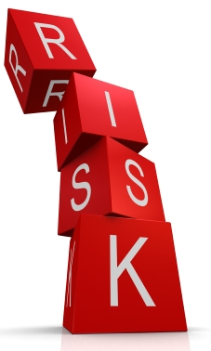
As part of managing the health and safety of the council you must control the risks in your workplace. To do this you need to think about what might cause harm to people and decide whether you are taking reasonable steps to prevent that harm. However, it is not just your duty to assess risk. It is the responsibility of everybody in the workplace to become involved in the process of Risk Assessment.

What is a Risk?
It is the likelihood of a hazard causing harm, loss, injury or other adverse consequences. Even after a Risk Assessment has been carried out, the hazard may still be there, but the risk will be reduced. If you see anything in your workplace that you think is a risk to yourself or others, it should be risk assessed.

What is a Hazard?
It is anything that has the potential to cause harm, loss or damage, such as working with vehicles, at height, with electrical equipment, in confined spaces, with chemicals, with DSE, with naked flames and manual handling. Be on the lookout for potential hazards that may pose a risk to yourself or others.

Why conduct Risk Assessments?

Fulfil legal requirements | All organisations must undertake Risk Assessments. Non-compliance may result in a fine and/or imprisonment.
Reduce accidents and illnesses | Being able to identify hazards and risks in workplace will help reduce level of accidents.
Reduce cost | Accidents and property loss in workplaces is very expensive to organisations. Risk assessing can effectively reduce costs.
Improve quality | It will improve quality of the workplace and working conditions.
Improve staff morale | By providing a safer working environment.
Good management practice | It is good practice to take all practicable steps to prevent accidents or loss in the workplace.
Improve resource allocation | It can be used in the allocation of resources, both in control of a hazard or in prevention of risks involved with a particular hazard.

Risk Assessments are not complicated. Use your common sense and your own knowledge of the job.

The legal requirements

Health and Safety at Work Act
Employers: Must ensure the health, safety and welfare at work of all employees.
Employees: Must take reasonable care of the H&S of themselves and others who may be affected by their acts of omission.

The Management of Health and Safety at Work Regulations
Employers to carry out risk assessments, make arrangements to implement necessary measures, appoint competent people and arrange for appropriate information and training

Five Key Steps to Risk Assessment
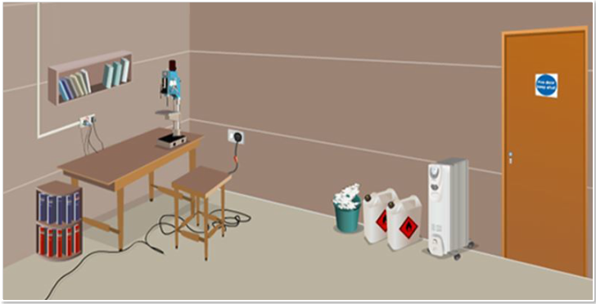
Drill without guard
Chemicals on floor
Electrical wires on floor
Fire door

The hazards in the picture are highlighted.

What could be done to reduce risks? Here are some ideas.

Drill without guard - attach a guard to reduce the risk of serious injury or entanglement.

Electrical wires on floor - cover with a cable bridge or reroute to a safer place. Install warning signs or remove and store them when not needed. This will reduce the risk of serious injury by tripping.

Chemicals on floor – Is the chemical needed? Can it be disposed of in a correct and safe manner? If needed, take it to a safe chemical store. Risks such as serious skin injuries, loss of life and property due to a fire, will be reduced.

Fire door – keep the fire door shut to reduce the risk of fire spreading.

Identify who could be at risk for each of the hazards. It will include anyone who may come close to, or be affected by the hazard. This could be employees, contractors, customers, clients, visitors, and the public.

Is it likely to cause harm, injury, illness or loss? Is it likely to happen? How often? How many people will be affected? How widespread can the damage be? Does more need to be done to reduce the risk?
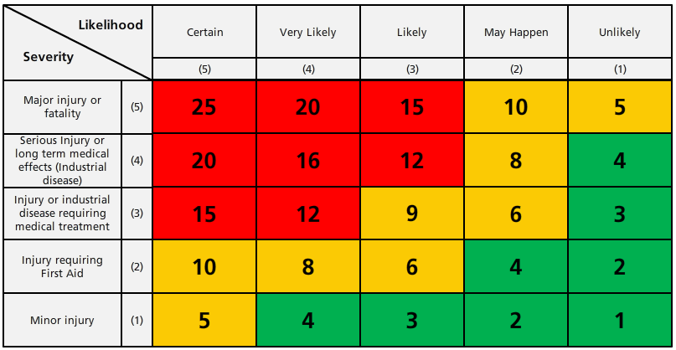
Quantify the level of risk (high, medium or low) using this matrix.

The number scored is the residual risk factor. See the next page for the risk ratings.

12 - 25 – Risk rating – High
The risk level is unacceptable as there is a probability of major harm occurring. A high level of control is required; permits to work, specialist equipment, strict supervision. Actions required: alternative methods that remove or reduce the risk. Must be strictly controlled and only authorised, competent persons are allowed in/around the hazard.

5 - 10 – Risk rating - Medium
Moderate level of control measures required; as before, but with engineering and management safety systems in place. Actions required: review to see if the risk can be reduced. Ensure competence levels for safe working or operation.

1 - 4 – Risk rating - Low
Low level of control measures required; adequate supervision, training and information. Actions required: review regularly to ensure that the risk does not increase.

Monitor and review the Risk Assessment on an ongoing basis and keep it up to date. Have there been any changes? Are there improvements that need to be made? Have employees identified a problem? Have you learnt anything from accidents or near misses? Use the Hierarchy of Controls below for reducing risks.

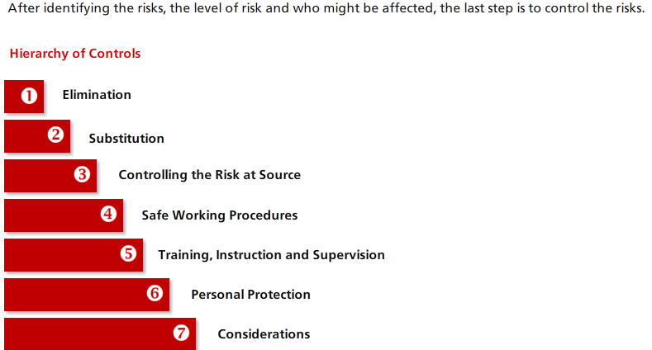
Remove the hazard wherever possible
If it can’t be removed, replace it with something less hazardous
Requires special procedures in place to separate and isolate hazard and reduce risk
Put in place to ensure risk is reduced as much as possible
Key elements in controlling hazards and reducing risks
Risks monitored by competent staff. PPE is a last resort. All other methods or risk reduction must be taken first.
Adequate first aid and emergency facilities available. Facilities must reflect risks.
Remember – If you do not conduct Risk Assessments the cost will be far higher than the cost of assessing the risks.

Further resources
SWP Risk Assessment
e-learning module on My Learning: e-learning – H&S – Safety Media – Risk Assessment
Face-to-face training on My Learning: Health & Safety Risk Assessment (General & Significant)

