Community Right to Bid

Asset of Community Value Register

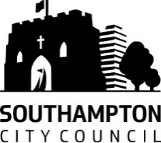
Unsuccessful Nominations

CRTB/008 – The Avenue pub, 1 Padwell Road, Southampton, SO14 6QY

Date of Nomination: 3rd September 2015

Nomination Valid: Yes

Decision: Not to List

Decision Date: 29th October 2015

Reason: Closed Public House, unlikely to re-open for this use in future since a number of attempts by tenants to operate have been unsuccessful. Site sold for redevelopment.

CRTB/010 – The Gordon Arms, 113 Portswood Road, Southampton, SO17 2FU

Date of Nomination: 1st March 2016

Nomination Valid: Yes

Decision: Not to List

Decision Date: 16th May 2016

Reason: There is no compelling evidence of substantial community use or wellbeing as required under the legislation and Government guidance.

CRTB/011 – The Wellington Arms, 56 Park Road, Southampton, SO15 3DE

Date of Nomination: 18th April 2016

Nomination Valid: Yes

Decision: Not to List

Decision Date: 13th June 2016

Reason: The evidence provided did not show that the community usage was any greater than what would be expected of a public house.

