Hackney Carriage and Private Hire Vehicle Accident Report Form
Sections 50(3) Local Government (Miscellaneous Provisions) Act 1976
If a licensed vehicle is damaged, and that damage affects the safety, performance and appearance of the licensed vehicle or the comfort or convenience of persons carried then the accident MUST be reported in writing within 72 hours of the accident. The vehicle’s proprietor is required to use this form to report the accident. Details must be accurate and complete.
Section 1: Organisation Details
Vehicle Proprietor(s)
Address
Email |  | Telephone
Section 2: Vehicle & Driver Details
Hackney or Private Hire
Plate Number |  | Plate Expiry
Registration Number |  | Colour
Make & Model
Driver |  |  | Badge Number
Section 3: Accident Details
Date |  | Time
Location
Weather
Accident Circumstances
Please describe how the accident occurred including details of all vehicles involved

Photos taken at scene? | Yes / No
Section 4: Reporting Details
Reported to police? | Yes / No
Incident Number
Section 5: Vehicle Damage Details
Was the vehicle recovered or driveable following the incident?
Please provide details of the vehicles current location and any Recovery/Storage company.

Section 5: Vehicle Damage Details (Continued)
Accident Sketch
Please mark the areas damaged in the accident on your vehicle in the below diagram: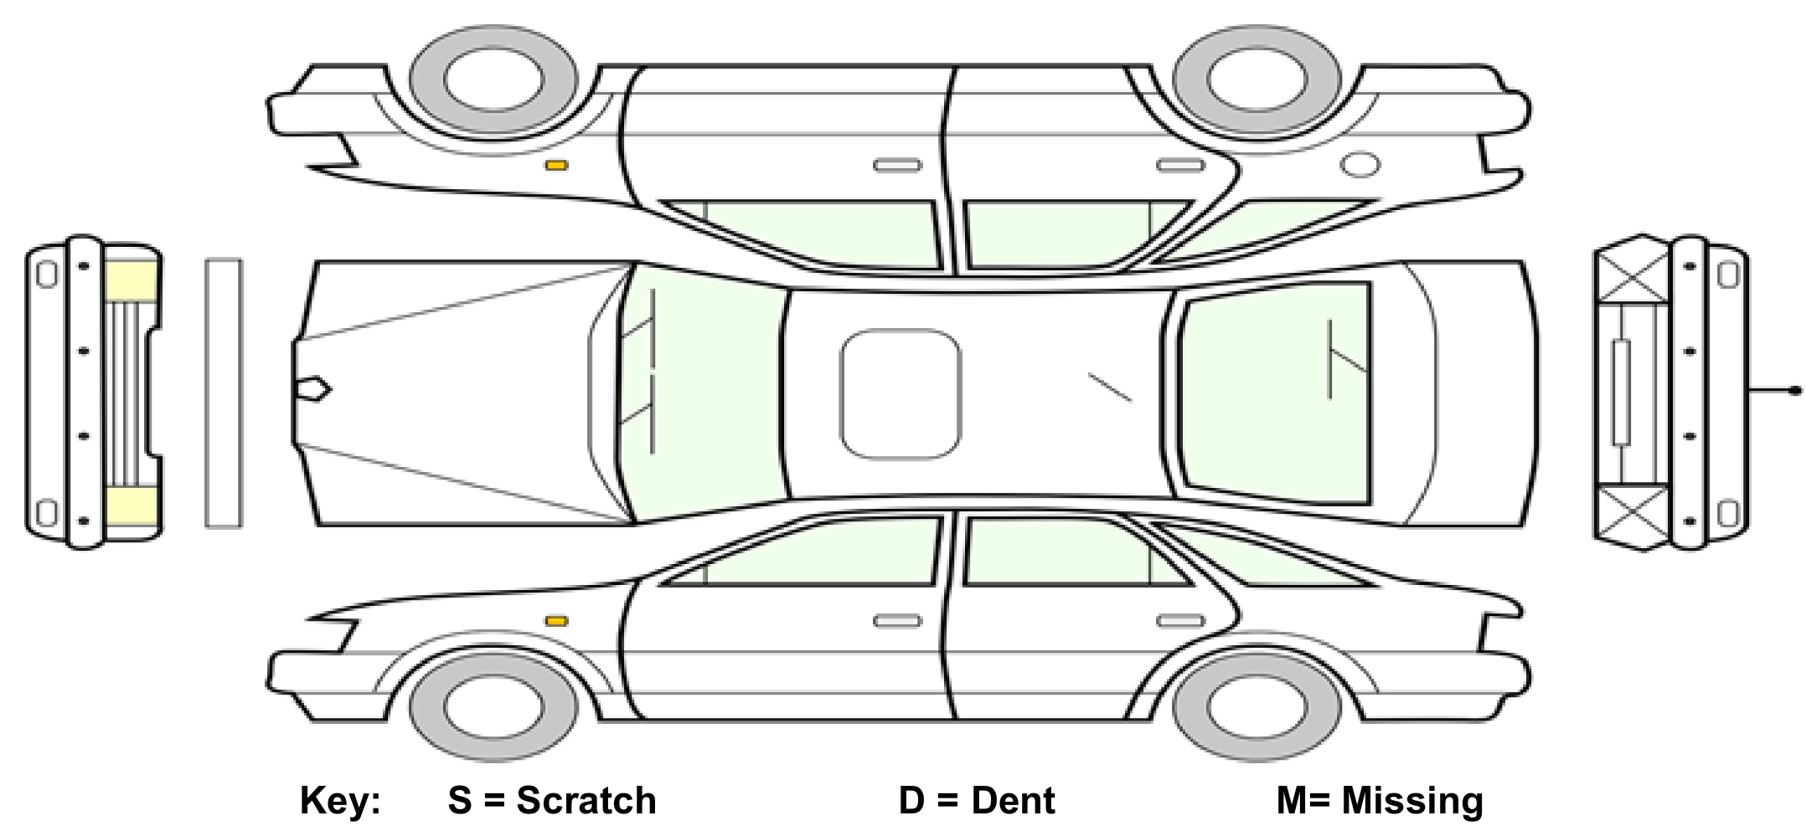

Mileage at time of accident
Damages & Severity
Please describe the damages in each marked area, including its severity:

FOR OFFICE USE ONLY:

Inspection Comments
Section 6: Injury Details
Were you (or the driver if completed by anyone other than the driver) injured? | Yes / No
If yes, please describe injuries sustained and if ability to drive was affected
Time off work? | Yes / No
Medical advice sought? | Yes / No
Were any passengers present in the vehicle at the time of the incident? | Yes / No
Passenger name
Passenger address
Did the passenger(s) appear to be or report any injuries? Please provide details
Was an ambulance called to the scene? | Yes / No
Section 7: Other Vehicle Details
Registration, Make and Model
Other vehicle driver name
Other vehicle driver address
Other vehicle driver contact details
Did the other vehicle contain have any passengers? | Yes / No
Did the other driver, or their passenger(s), appear to be or report any injuries? Please provide details

*Please provide details of further vehicles and individuals overleaf.

Section 8: Replacement Vehicle
Has provision been sought for a replacement vehicle? | Yes / No
Replacement vehicle provider
(including telephone)

Replacement Vehicle Registration, Make & Model
Date of commencement:

Declaration:

I believe that the facts stated in this accident report form are true. I understand that proceedings for contempt of court may be brought against anyone who makes, or causes to be made, a false statement in a document verified by a statement of truth without an honest belief in its truth

Signed: |  | Date:

Insert details of where to return the completed form here.

FOR OFFICE USE ONLY:

Decision | NFA |  | Suspend |  | Refer  Retest |  | 7 days |  |  | ____days |  |  | Other

Suspension Notice Number

Further Comments

Inspectors  Signature |  | Date:
Additional Notes:

